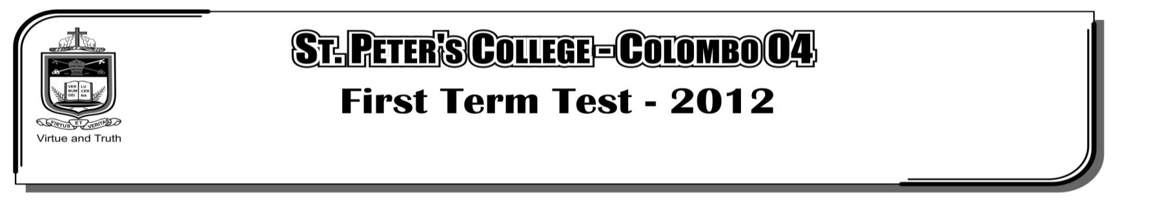

**THIRD TERM EXAMINATION - 2021**

**GRADE 09 – Physical Education**

**02 Hours**

**Part - I**

**Select the correct answer.**

01. These are sports activities that are designed to develop skills of major games. They are known as,

i. Organized games ii. Minor games

iii. Lead up games iv. Major games

02. A skill in football is,

i. Service ii. Setting iii. Heading the ball iv. Attacking

03. Which category does long jump fall into,

i. Vertical jump ii. Horizontal jump

iii. Throwing events iv. Lead up games

04. Which start technique is used in 100m?

i. Crouch start ii. Medium start iii. Standing start iv. Elongated start

05. An organized game is,

i. Football ii. Nerenchi panima iii. Onchili padema iv. Kick ball

06. Which physical fitness factors develop through walking fast, riding bicycles, swimming,

i. Flexibility ii. Muscular endurance

iii. Muscular strength iv. Cardiovascular endurance

07. Which country hosted the first Olympic games?

i. Australia ii. Canada iii. Athens iv. South Africa

08. Which is the way defending should not be done in Netball?

i. Defending the player ii. Defending the player

iii. Defending the position iv. Defending the post

09. Non visual pass method is used for,

i. 1500m x 4 ii. 100 x 4 iii. 400 x 4 iv. All correct

10. What is the given time to do a throw, to start after the number is announced?

i. 3 min ii 2 min iii. 1 min iv. 4 min

11. What is the next technique after the takeoff in long jump?

i. Landing ii. Flight iii. Sail technique iv. Approach run

12. Which is not a common feature of an organized game?

i. Number of players are specified.

ii. Can be used any equipment.

iii. There are accepted rules and regulations.

iv. Play grounds with standard measurements are used.

13. Which fitness will be measured by using the Body Mass Index (BMI)

i. Speed ii. Flexibility iii. Endurance iv. Body composition

14. In football, “throw in” is used,

i. To finished the game ii. To restart the game

iii. To score a goal iv. To throw the ball in to the goal

15. Which is used to tie a rope to the handle of a bucket?

i. Clove hitch ii. Bowline knot iii. Reef knot iv. Sheet bend

16. “Flat Rock Fire” is not to used for cooking.

i. Baked food ii. Baked rotties iii. Cook rice iv. Bake meat

17. Which is an Air Sport,

i. Ski jumping ii. Wind surfing iii. Sky diving iv. Water polo

18. A special approach run is used for this event,

i. Shot put ii. Javelin throw

iii. Hammer throw iv. Discuss throw

19. The specific physical fitness component, a tennis player should have is,

i. Speed ii. Endurance iii. Coordination iv. Strength

20. What is the advantage of sitting correctly?

i. Feeling of pain ii. Bad appearance

iii. Muscle injury iv. Mental and physical satisfaction

21. What is a factor of physical fitness?

i. Speed ii. Strength

iii. Endurance iv. All correct

**(1 x 20 = 20 Marks)**

**Part - II**

**Answer all questions.**

01. i. Explain what are “organized games” **(02)**

ii. Write 3 common features of organized games. **(03)**

iii. Write 3 outdoor educational actives. **(03)**

iv. Write 3 benefits of engaging in outdoor activities. **(02)**

**(10 Marks)**

02. i. Name 3 factors that should be considered when making fire, during outdoor activities. **(03)**

ii. Name the 4 types of bonfires? **(02)**

iii. Name the main food items that can be cooked outdoors. **(02)**

iv. Write the 4 names of fire places that are used to cook food outdoors. **(03)**

**(10 Marks)**

03. i. What are the techniques of high jump? **(02)**

ii. What are the 4 phases that consists of each techniques of long jump? **(02)**

iii. Write an activity to develop skills in long jump. **(03)**

iv. Write the 3 rules related to the baton change. **(03)**

**(10 Marks)**